## 0. Introduction

### 1. Why use a database

### 2. What you should know

### 3. Prerequisites

### 4. Understanding databases - Benefits of spreadsheets

### 5. Understanding databases - Benefits of structured data

### Chapter Quiz

Question 1 of 4

When you move data from an unstructured form to a structured form, what benefit do you gain?

the ability to use data programmatically

Incorrect

Organized data is a lot easier to use for other purposes. Think about how much easier it would be to print address labels from a spreadsheet than from a freeform list of information.

all of these answers

Correct

Simpy putting your data into an organized structure, like a spreadsheet or table, brings a lot of benefits.

the ability to easily locate data

Incorrect

When data is organized, it's easier to find. And organized data is useful for other purposes as well.

the ability to easily sort data

Incorrect

Organizing data in a spreadsheet or table allows you to sort the data, but it also brings other benefits.

Question 2 of 4

When you store data in a database, what is one advantage you get over a plain spreadsheet?

Rows of data can be associated with each other across tables.

Correct

While some spreadsheets can simulate this capability with lookup functions, the ability to create relationships between tables is a core function of relational databases.

You can keep information stored in a regular, organized way.

Incorrect

A spreadsheet keeps information in a regular, organized way. Databases do, too. But databases have some other features some spreadsheets lack.

You can insert and delete rows of data.

Incorrect

You can accomplish this with spreadsheets. Think about features that databases offer, and some spreadsheets don't.

Data can be sorted by column.

Incorrect

Data in spreadsheets can easily be sorted by column. Try again.

Question 3 of 4

What is one advantage of using a spreadsheet to store data?

It protects data from becoming inconsistent.

Incorrect

Most spreadsheets don't enforce any kind of data integrity.

It ensures that the data is correct.

Incorrect

While a spreadsheet helps you organize data, it doesn't ensure that the data is correct.

It protects data from unauthorized changes.

Incorrect

Spreadsheets can offer security, but security is not a feature unique to spreadsheets.

It can help you see gaps in the data.

Correct

When pieces of information are arranged in a consistent way, it becomes easier to see what information you have.

Question 4 of 4

The definition of how data in a database will be organized is called the _____.

settings

Incorrect

Some settings are included in the definition of the database, but there's a different name for the collection of table and database information.

schema

Correct

The database's schema includes the information about the layout of tables and other information about the database itself.

tables

Incorrect

Tables are included, but there's more information than just table definitions. And there's a different name for it.

layout

Incorrect

While the layout of tables is included in this definition, there's a different term for the result of your scheming about the database's design.

## 1. Database Foundations

### 1. Relational databases

### 2. Keys and unique values

### 3. Relationships

### 4. ACID and transactions

### 5. Basic SQL

### Chapter Quiz

Question 1 of 14

A unique value _____.

almost never repeats

Incorrect

The definition of a unique value is that it never repeats in a given column. If it repeats at all, even just a little bit, it's not unique.

occurs only once in a given table

Incorrect

Some unique values may only occur once in a given table, but when you think about unique values, you consider rows, not whole tables.

occurs only once in a given column

Correct

Unique values are useful because they never appear twice. If a value appears more than once in a given column, it's not unique in that column.

occurs only once in a given row

Incorrect

Rows can contain fields that hold the same values. When you consider unique values, you think about columns, not rows.

Question 2 of 14

A relationship connects two pieces of data in different _____ in the same _____.

rows; databases

Incorrect

While you can construct relationships between databases manually, you lose consistency guarantees. Traditionally, relationships stay within the same database.

columns; table

Incorrect

The columns in a table are considered a relation, but a relationship links tables.

fields; row

Incorrect

A relationship does not operate between fields in a row.

tables; database

Correct

Even though a relationship is concerned with individual rows, a relationship is defined as being between tables in the same database.

Question 3 of 14

Which is a good example of a candidate key?

a customer's first name

Incorrect

It's very common for people to share first names. Names are not usually candidate keys.

an employee ID number

Correct

Any piece of data that uniquely represents a row is a candidate key, and if you have a value that occurs in the data naturally, that's a natural key.

an employee's birthday

Incorrect

While it may happen to be the case that each of your employees has a different birthday, it's possible for people to share a birthday, so this not a candidate key.

a customer's favorite movie

Incorrect

A value that might change over time is not a value that should be used to uniquely identify a record. Preferences can change, but identifiers shouldn’t.

Question 4 of 14

How many SQL clauses are in this query?

SELECT Width,Height FROM Shapes;

three

Incorrect

Clauses are defined by keywords, not the parameters within the statement.

one

Incorrect

A single SQL statement usually consists of multiple clauses, defined by keywords.

five

Incorrect

Not every element in an SQL statement is a separate clause.

two

Correct

Each keyword, SELECT and FROM, defines a single clause.

Question 5 of 14

In a database, what is a relation?

a set of attributes (columns) that describe information about specific instances (rows) of an entity

Correct

You may also see the rows called "tuples."

the way in which information in one table connects to the information in another table

Incorrect

This is a relationship, which sounds similar but has a different meaning. A relation groups information with similar attributes together in an organized way.

one column of information

Incorrect

A relation is composed of related attributes, and so there needs to be more than just one attribute.

two pieces of data on one row that are connected in meaning

Incorrect

Two pieces of information on a row may be related to each other, but a relation describes a grouping of attributes.

Question 6 of 14

Which of these images indicates a *row* in a *table*?

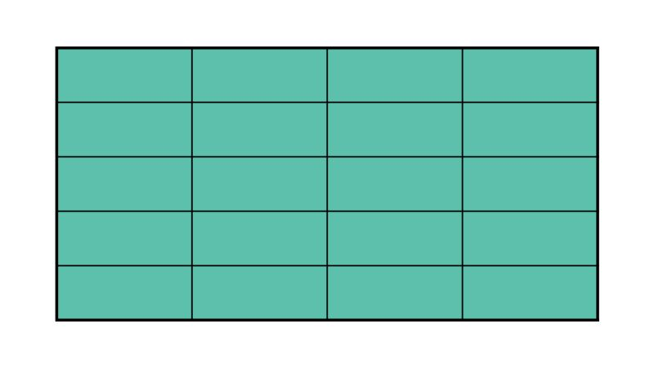

Incorrect

This indicates a table, or relation--a collection of entities and their attributes.

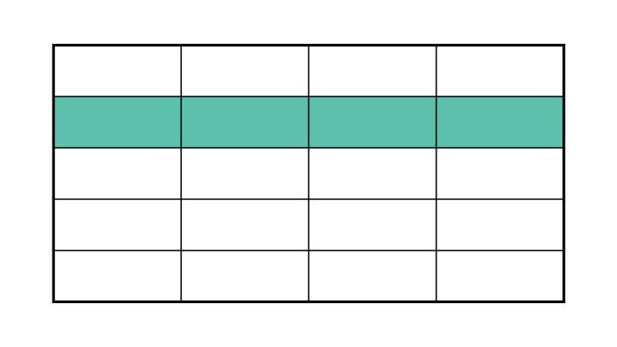

Correct

This indicates a row, or a record, which contains information pertaining to one instance of an entity.



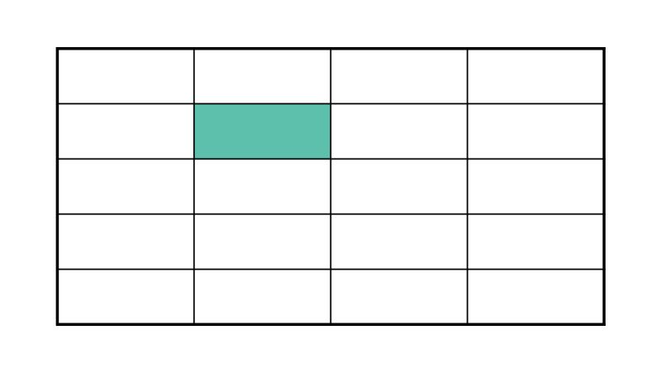

Incorrect

This indicates a cell, one specific attribute of one specific instance of an entity.



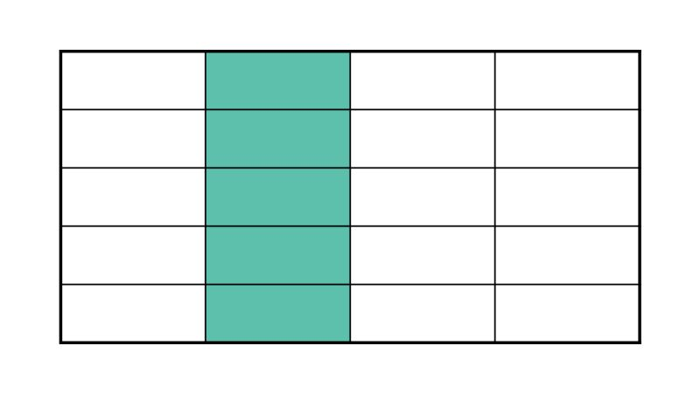

Incorrect

This indicates a column, or one set of attributes for one or more instance of an entity.

Question 7 of 14

What is the name of a key that consists of different fields taken together to act as a unique identifier?

foreign key

Incorrect

A foreign key is the primary key from one table that is referenced in another table.

surrogate key

Incorrect

A surrogate key is actually an auto-incremented counter added synthetically to a table to provide uniqueness.

composite key

Correct

A composite key combines two or more fields to act as a unique identifier.

primary key

Incorrect

The primary key is simply the most important key in a given table.

Question 8 of 14

Which ACID step requires that the database is updated when the transaction completes successfully?

durable

Correct

Durability requires that data changed by the transaction is written to the database.

changed

Incorrect

"Changed" is not actually a step in the ACID model.

atomic

Incorrect

The "atomic" requirement refers to divisibility of the transaction, not its outcome.

isolated

Incorrect

The "isolated" requirement actually refers to the data that is altered by other actions.

Question 9 of 14

When is an associative table useful?

when a table needs to have additional columns added

Incorrect

An associative table is used to define relationships between tables, not to extend a single table.

when records need to be related in a many-to-many relationship

Correct

An associative (or linking) table relates foreign keys from different tables to associate their records.

when a large table can be condensed into a smaller table with no duplicates

Incorrect

An associative table is not replacing or altering existing tables, but adds one other table to connect them.

when a record needs to be matched with its counterpart in a one-to-one relationship

Incorrect

An associative table is actually less useful in a one-to-one relationship.

Question 10 of 14

In the ACID model, which term represents the fact that a transaction can't be divided into smaller parts?

consistent

Incorrect

Consistency means that the transaction preserves the integrity of data in the database. There's another term for the idea that a transaction can't be treated as smaller pieces.

atomic

Correct

Even though you now know atoms can be broken down into smaller parts, the term atomic means that something can't be broken down into smaller pieces. Here, atomicity means that the transaction behaves as one single action.

durable

Incorrect

Durability means that when the transaction is complete, the data has been changed in a way that will persist. While the term durability sounds like something that can't be broken into smaller parts, you use a different term to represent that.

isolated

Incorrect

When dealing with transactions, isolation means that the database won't change while the transaction is taking place. This could be as a result of one query or a series of them. The idea of a transaction not being broken into smaller pieces has a different term.

Question 11 of 14

What would you use a relationship to connect?

a customer's first name and last name

Incorrect

Because a first and last name are both characteristics of one customer, they would appear in the same row. You wouldn't use a relationship to connect these pieces of data.

a customer's email address and phone number

Incorrect

A customer's email address and phone number are both pieces of data that you'd store in one table of customer information. So there's no relationship to define.

a customer with their favorite table in the restaurant

Correct

This would be a one-to-many relationship. For every one table, there could be many customers who prefer to sit at it. But one customer cannot have many favorite tables.

the price of a dish and the name of that dish

Incorrect

The price of a dish and its description should both appear in a row describing that dish. There's no relationship to be defined here.

Question 12 of 14

SQL is _____.

a database management system

Incorrect

While many DBMSs use SQL, SQL itself is a language, not a DBMS.

the language you use to communicate with a database

Correct

Structured Query Language is the most common language interacting with relational databases.

only used by professional database administrators

Incorrect

DBAs will use SQL quite a bit, but developers, scientists, and business analysts will also find it very useful to know.

outdated and obsolete

Incorrect

SQL is pretty old as languages go, but it's by no means obsolete. It's a fundamental language in data science, development, and other fields.

Question 13 of 14

What does the term transaction mean?

all of the steps for an action must be completed

Correct

A transaction is a collection of steps that must all be completed in order for a change to be made to the database.

the action is transferring data from one cell to another

Incorrect

A transaction doesn't require a transfer or translation of data. You can use transactions to create or remove data just as easily.

the action being taken is financial in nature

Incorrect

You often think of transactions being financial in nature, but the term refers to a set of actions, not anything specifically having to do with money.

the action was initiated by a customer

Incorrect

Some customer activities will involve transactions, but you can use them elsewhere, in maintenance or automatic procedures.

Question 14 of 14

In the acronym CRUD, what does "R" stand for?

remove

Incorrect

To remove something from the database, you'd delete it.

read

Correct

The letters stand for create, read, update, and delete. Good job!

revise

Incorrect

If you want to revise the information stored in the database, you'd update something.

retrieve

Incorrect

When you go to retrieve information from the database, there's a different term you use to talk about that.

## 2. Tables

### 1. Modeling and planning a database

### 2. Naming tables

### 3. Columns and data types

### 4. Numbers and other types

### 5. Primary and foreign keys

### Chapter Quiz

## 3. Relationships

### 1. Creating relationships

### 2. One-to-many relationships

### 3. Many-to-many relationships

### 4. One-to-one relationships

### 5. Relationship rules and referential integrity

### Chapter Quiz

## 4. Database Optimization

### 1. Normalization

### 2. First normal form

### 3. Second normal form

### 4. Third normal form

### 5. Denormalization

### Chapter Quiz

Question 1 of 11

Second Normal Form tells you to _____ in addition to being compliant with First Normal Form.

remove repeating groups

Incorrect

Being compliant with 1NF takes care of this for you. 2NF has to do with composite keys.

ensure that no non-key field is dependent on only part of a composite key

Correct

Before you get to 2NF, you need to make sure your tables have no repeating groups.

ensure that no non-key field is dependent on the entire composite key

Incorrect

If you're using composite keys, the whole idea is that non-key fields are dependent on the key. Try again.

ensure that no non-key field is dependent on another non-key field

Incorrect

This is jumping ahead. Before moving to 3NF, you should take a look at your composite keys.

Question 2 of 11

If you can figure out the value of one non-key field in a row by looking at another non-key field in that same row, what do you violate?

Second Normal Form

Incorrect

2NF deals with key fields, specifically composite keys. Try again.

the rules of the space-time continuum

Incorrect

It's not so dramatic--storing derived data is wasteful, but it won't tear reality apart.

First Normal Form

Incorrect

1NF deals with repeating groups, not derived data.

Third Normal Form

Correct

3NF tells you that each field in a row should represent something unique about a record.

Question 3 of 11

Which of these tables is in Second Normal Form? Assume that the Class and Date fields are being used as a composite key.

A table with 3 columns, the first of which labeled Room is sorted first by data from the Date column, then further sorted by data from the Class column.

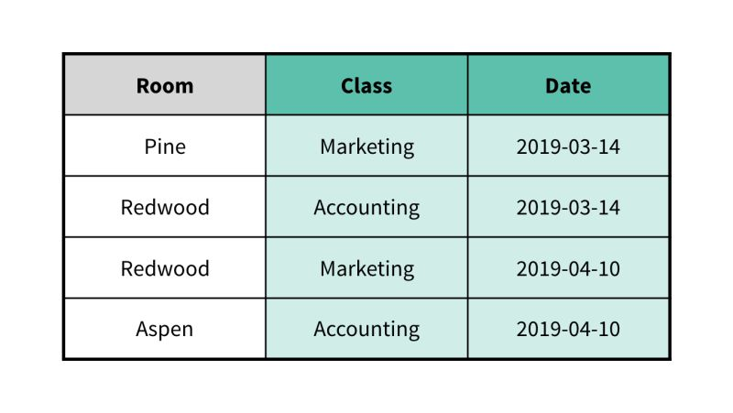

Correct

This table is in Second Normal Form. No non-key field is dependent on only part of the key.

A table with 4 columns, the first of which labeled Room is sorted first by data from the Date column, then further sorted by data from the Class column, and a fourth column labeled Instructor that is only sorted by data from the Class column.

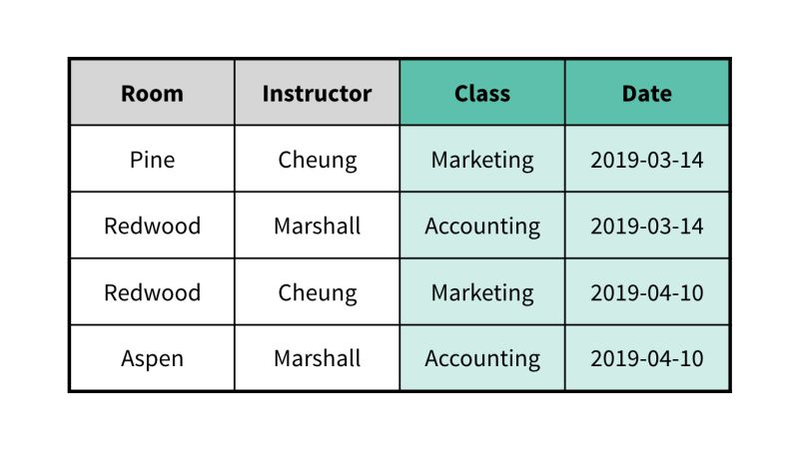Incorrect

This table is not in Second Normal Form. The instructor appears to be based on the class, not on the full composite key of Class and Date.

A table with 4 columns, the first of which labeled Room is sorted first by data from the Date column, then further sorted by data from the Class column, and a fourth column labeled Book that is only sorted by data from the Class column.

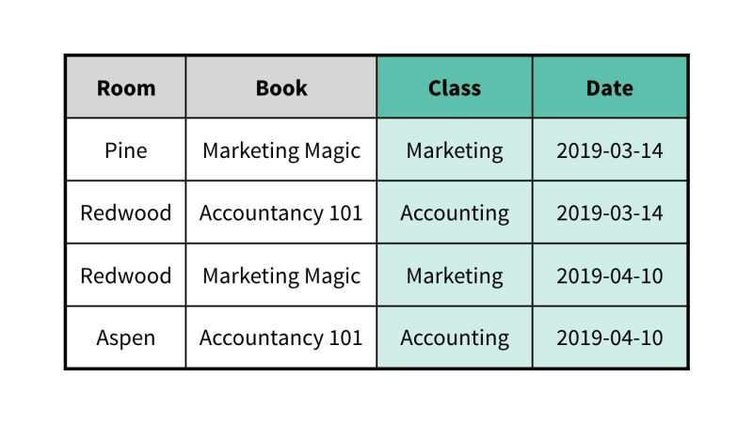

Incorrect

This table is not in Second Normal Form. The book appears to be based only on the Class, not the full composite key of Class and Date.

A table with 4 columns, the first of which labeled Room is sorted first by data from the Date column, then further sorted by data from the Class column, and a fourth column labeled Quarter that is only sorted by data from the Date column.

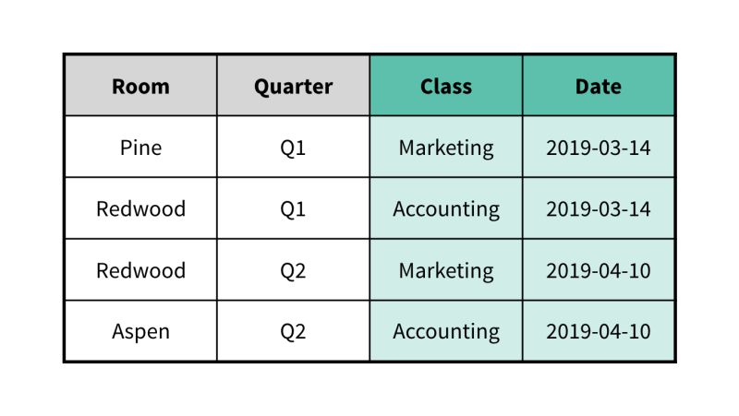

Incorrect

This table is not in Second Normal Form. The quarter of the class appears to be based on only the date the class is offered, not the full composite key of Class and Date.

Question 4 of 11

In order to put a database into Third Normal Form, _____.

it must also be in First and Second Normal Form

Correct

Normalization is a progressive process, and higher forms depend on the database being compliant with lower forms as well.

the database must contain three tablesthe database must contain three tables

Incorrect

Often, you'll need to create new tables while normalizing. But that's not always the case. You could have a database in 3NF with just one table. It just wouldn't be very interesting.

it must not be in either First or Second Normal Form

Incorrect

A database can't be in 3NF if it's not already in 1NF and 2NF.

you can skip right to Third Normal Form

Incorrect

In order to be in 3NF, a database must first comply with 2NF, which means it also needs to comply with 1NF.

Question 5 of 11

What does denormalization refer to?

storing different types of data in a particular column

Incorrect

In a relational database, each column must contain only one specific type of data.

only complying with Third Normal Form and skipping the first two

Incorrect

You can't comply with 3NF and not the other two. Denormalization is a separate step from normalization.

skipping the normalization process

Incorrect

Denormalization should happen after normalizing the database, and only if there's a business justification for reducing the integrity and consistency of the database in exchange for speed.

consciously choosing to violate the rules of normality in order to improve speed or for some other business reason

Correct

Denormalization is usually a trade-off between speed and integrity.

Question 6 of 11

Which of these tables is in *Third Normal Form*?

* 

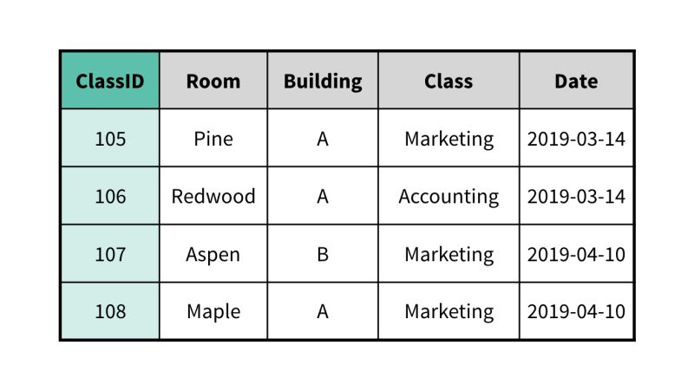

Incorrect

This table is not in Third Normal Form. Knowing which room a class is held in, you also know the building. So the building is dependent on a non-key field.

* 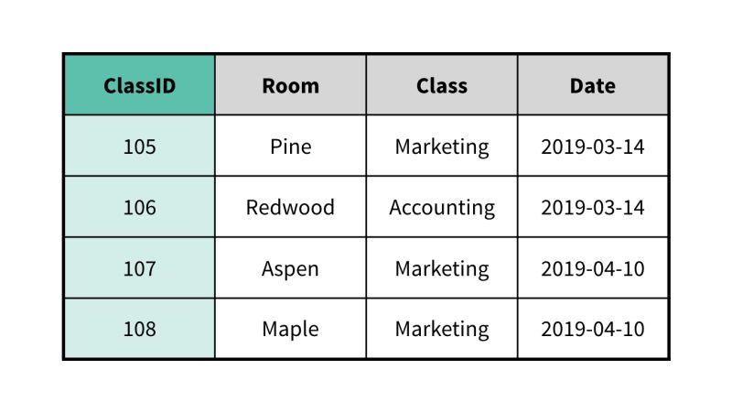

Correct

This table is in Third Normal Form. Each non-key field describes something unique about a given class based on ClassID.

* 

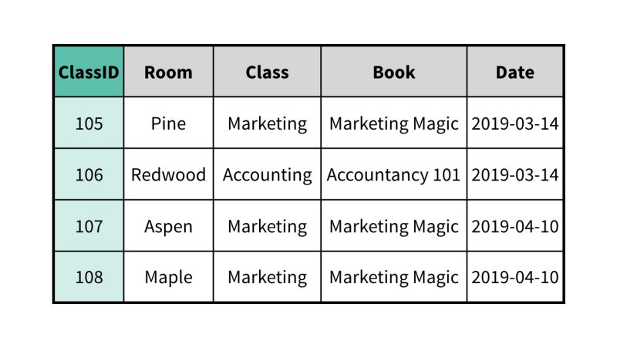

Incorrect

This table is not in Third Normal Form. Knowing which class is offered, you know the book that will be used. In this case, the book is determined by a non-key field.

* 

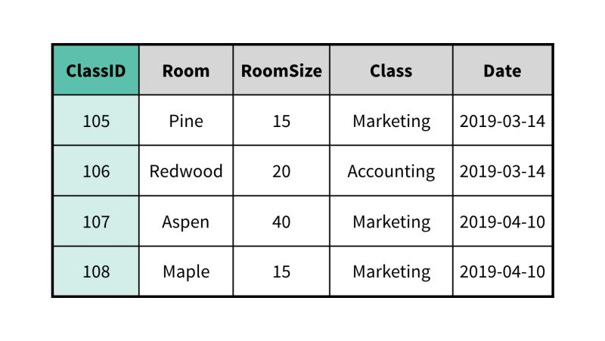

Incorrect

This table is not in Third Normal Form. The capacity of the room depends on which room you're looking at (a non-key field).

Question 7 of 11

First Normal Form tells you to do what?

check that data in fields matches the data type specified for them

Incorrect

The database takes care of this for you--data types aren't involved in normalization.

remove repeating groups

Correct

If you find yourself adding lists of things in individual fields or adding columns to represent additional fields of the same type, you're probably creating repeating groups. And 1NF tells you that you need to refactor your tables if that happens.

ensure that no non-key field is dependent on only part of a composite key

Incorrect

Before you get to 2NF, you need to make sure your tables have no repeating groups.

ensure that no non-key field is dependent on another non-key field

Incorrect

If you can derive the data for one field from another field that isn't a key, that's a violation of 3NF. 1NF has a different goal.

Question 8 of 11

When might you choose to denormalize a table?

You don't have time to follow the normalization process.

Incorrect

Even if it takes some time, you should follow the normalization process in any database.

There is never a benefit to denormalizing a table.

Incorrect

Denormalization is a choice to make after following the normalization process. It can provide benefits but also introduces consistency threats.

Retrieving the data upon request would be slow or burdensome, and you are able to pre-calculate or store a copy of the data somewhere it can be retrieved faster.

Correct

If you need to prioritize the speed of a particular operation, you might choose to denormalize, as long as you remain aware of the threat to database integrity.

Our tables are small, and normalization is not a concern.

Incorrect

Regardless of the amount of data stored in a database, normalization helps to improve consistency.

Question 9 of 11

What does normalization help you do?

reduce redundancy

Incorrect

Normalization guides you toward organizing data in a way that reduces the number of times the same data appears in different places. There are other benefits as well.

accomplish all of these goals

Correct

The normalization process provides a framework to think about how data is organized.

improve integrity

Incorrect

Normalization gives you insight into how data will be affected if other data is changed. There are other benefits as well.

organize tables

Incorrect

As you follow the rules for normalizing a database, you will refine the way your tables are organized and review what information they contain. There are other benefits as well.

Question 10 of 11

Which of these tables is in *First Normal Form*?

* 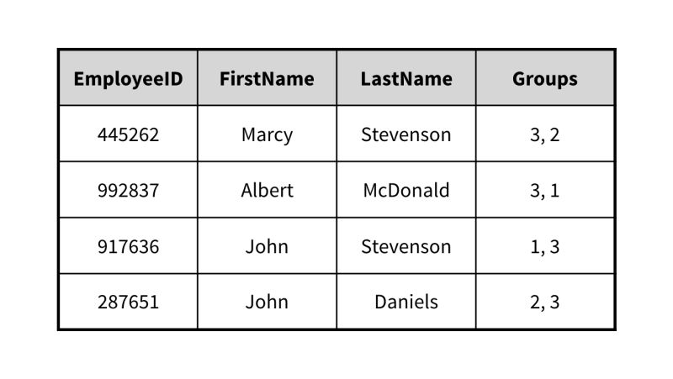

Incorrect

This table contains a column with more than one value in a column and does not satisfy First Normal Form.

* 

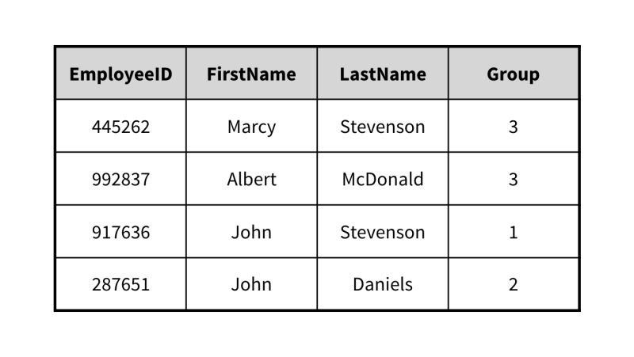

Correct

This table has no repeating groups and is in First Normal Form.

* 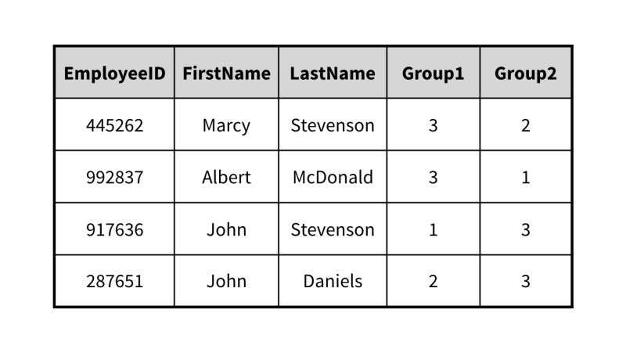

Incorrect

This table contains repeating columns and does not satisfy First Normal Form.

* 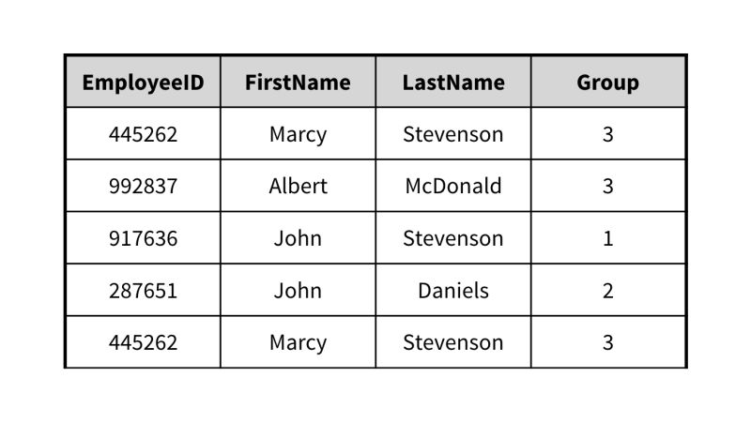

Incorrect

This table contains repeated rows and does not satisfy First Normal Form.

Question 11 of 11

A table has two rows with the same values in all columns. Which step can you take to have this table meet the first normal form (1NF) requirements?

Consolidate all table columns into a single column.

Incorrect

Other than altering the schema, this does not eliminate the repeating duplicate rows, and therefore still violates the 1NF requirements.

Delete one of the rows.

Incorrect

Deletion of a row would likely delete a viable record, so this action should be avoided.

Add a primary key to the table.

Correct

The primary key will add a unique value for each row, and thus eliminate the repeating duplicate rows issue.

Move both rows to the end of the table.

Incorrect

When both rows are moved to the end of the table, the duplicate rows still repeat, even if the sequence of rows is altered.

## 5. Querying a Database

### 1. Creating a database

### 2. Creating tables

### 3. Writing SQL queries

### 4. Narrowing query results

### 5. Sorting results

### 6. Aggregate functions

### 7. Joining tables

### 8. Modifying data

### Chapter Quiz

Question 1 of 24

What is the foreign key in the table created after this command?

CREATE TABLE Models (

ModelID INT(6) NOT NULL AUTO_INCREMENT,

Color INT(6) REFERENCES Colors(ColorID),

PRIMARY KEY(ModelID)

);

ModelID

Incorrect

The "ModelID" field is actually the primary key of the table.

Color

Correct

The "Color" field is the foreign key that references the ColorID field in the other table.

Colors

Incorrect

"Colors" is actually the other table that the foreign key references.

ColorID

Incorrect

"ColorID" is actually the primary key in the other table that the foreign key references.

Question 2 of 24

Which SQL command will you use to create a new database called "mydb"?

USE mydb;

Incorrect

This command is used to connect to an already-created database.

DATABASE mydb;

Incorrect

This command will result in an error because it does not specify the actual action to perform.

CREATE DATABASE mydb;

Correct

The "CREATE DATABASE" command is used to create a new database.

CREATE mydb;

Incorrect

This command will result in an error because it does not specify what to create.

Question 3 of 24

Which of these is not an example of a time when you would use an aggregate function?

looking up customers with the name Rafael Montresso

Correct

Aggregate functions are used to tell you about certain characteristics of multiple records. Requesting a record by specific field values is not an aggregate operation.

finding the highest price in a table of products

Incorrect

MAX()' is an example of an aggregate function.

counting the number of rows that match a specific query

Incorrect

COUNT()' is an example of an aggregate function.

finding the average of the values in the Points column in a table of quiz scores

Incorrect

AVERAGE()' is an example of an aggregate function.

Question 4 of 24

Which WHERE condition can you use to find all records containing a first name starting with the letter "A"?

WHERE FirstName LIKE "A%";

Correct

The percent symbol is used as a wildcard for anything coming after the letter "A."

WHERE FirstName = "A";

Incorrect

This query will just return all records containing a first name that is exactly "A."

WHERE FirstName LIKE "A*";

Incorrect

The asterisk in the specified string is not a valid wildcard in this context.

WHERE FirstName = "A%";

Incorrect

To filter using wildcards, the comparison operator cannot be an equal sign.

Question 5 of 24

When using an aggregate function, how many results do you expect?

one

Correct

Aggregate functions return one value that describes a set of data.

two

Incorrect

Aggregate functions return one result.

all of the records in a table

Incorrect

Aggregate functions return one result.

zero

Incorrect

Even operating on zero records, an aggregate function will return one result.

Question 6 of 24

What should come instead of the ??? placeholder for this query to return all fields and records in the table?

SELECT ??? FROM mytable;

FIELDS,RECORDS

Incorrect

The words "FIELDS,RECORDS" are interpreted as explicit field names to retrieve.

ALL

Incorrect

The word "ALL" is interpreted as a field name, not as a wildcard.

$

Incorrect

The dollar symbol is not the correct wildcard to use in SQL.

*

Correct

The asterisk is used as a wildcard to retrieve everything from the given table.

Question 7 of 24

In any given query, you can only join together a maximum of two tables.

TRUE

Incorrect

You can join together many tables as long as you tell the database which pairs of values on the tables are intended to match.

FALSE

Correct

You can join together many tables as long as you tell the database which pairs of values on the tables are intended to match.

Question 8 of 24

In order to use records from more than one table in a query, you need to _____ the tables based on some matching criteria.

match

Incorrect

Matching fields between the tables is an important aspect of the operation, which has a different name.

zip

Incorrect

You can visualize this operation zipping two tables together, but the activity has a different name.

blend

Incorrect

Though we're blending data from different tables, there's a different name for this operation.

join

Correct

Joining tables allows you to match rows from one table with rows on another table.

Question 9 of 24

If a table is set to auto-increment the primary key, you'll need to know the next value and set it manually when you enter a record.

TRUE

Incorrect

When the database automatically increments a key field, you don't need to worry about setting the value. The database will provide the next value in the sequence automatically.

FALSE

Correct

When the database automatically increments a key field, you don't need to worry about setting the value. The database will provide the next value in the sequence automatically.

Question 10 of 24

When modifying a record, it's a good idea to specify the record _____.

as precisely as possible, ideally using the primary key

Correct

If you've designed your database correctly, each record should have a key that uniquely identifies it, making it safe to use that key to modify a record.

choosing the most recently added result in a set of matching records

Incorrect

When using a search that matches more than one record, you can't be certain that the record you want is the most recently modified one.

choosing the last result in a set of matching records

Incorrect

When using a search that matches more than one record, you can't be certain that the record you want is last.

by choosing the first result in a set of matching records

Incorrect

When using a search that matches more than one record, you can't be certain that the record you want is first.

Question 11 of 24

Which of these search results is in *descending* order based on the DATE field?

* 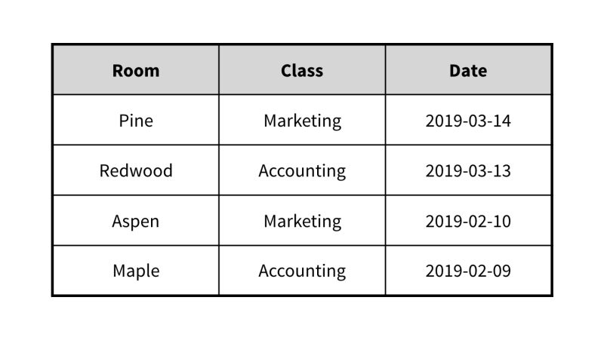

Correct

This result set is sorted by date, descending. The latest date is at the top, and the earliest is at the bottom.



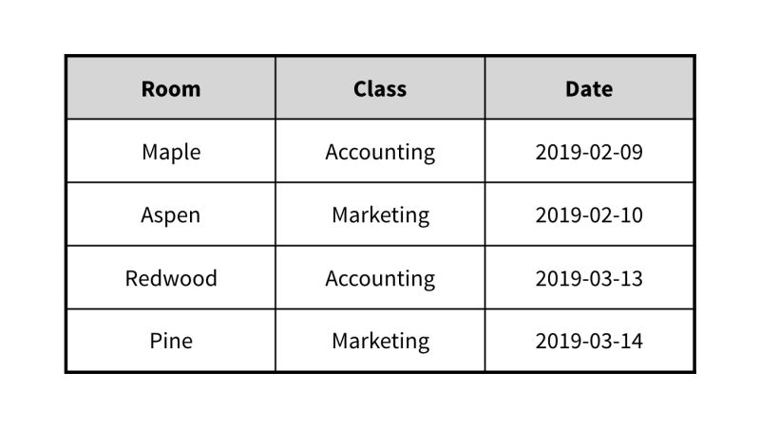

Incorrect

This result set seems to be sorted by date, in ascending order.

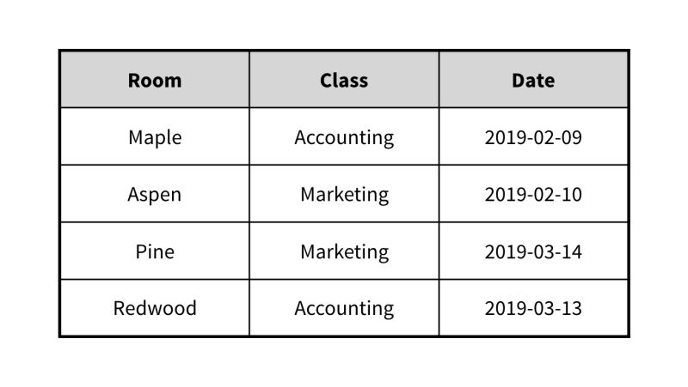

Incorrect

This result set does not seem to be sorted in any way.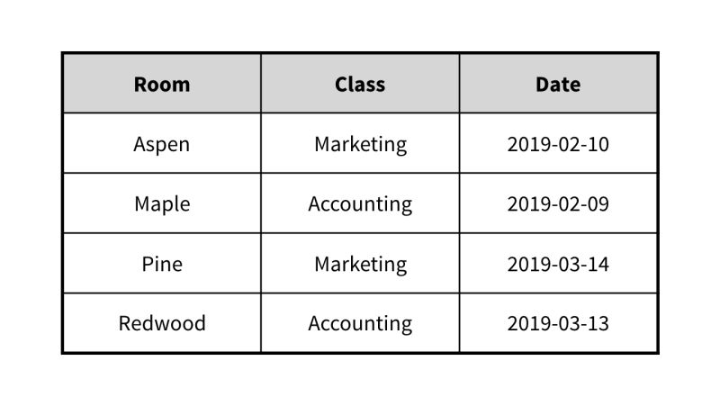

Incorrect

This result set seems to be sorted by room, in ascending order.

Question 12 of 24

In order to sort results based on a field, that field needs to appear in the final output.

TRUE

Incorrect

A field used for sorting doesn't need to appear in the 'SELECT' clause of the query.

FALSE

Correct

A field used for sorting doesn't need to appear in the 'SELECT' clause of the query.

Question 13 of 24

A SQL statement that returns requested records from the database is called:

a SQL keyword

Incorrect

SQL statements contain keywords, whether or not they return a requested set of records.

a SQL query

Correct

All statements return a status when executed, but a query is a special case of statement that returns information you asked for.

a SQL request

Incorrect

All SQL statements make a request of the database, but there's a different term for asking for and retrieving specific information.

a SQL question

Incorrect

You can think of it as asking the database a question, but there's a different term for this kind of statement.

Question 14 of 24

You can write SQL:

all of these answers

Correct

You can write SQL statements in any of these places.

in database management software

Incorrect

Most DBMSs provide a console where you can execute SQL statements. You can use SQL elsewhere, too!

in an app's source code

Incorrect

You can write SQL statements for apps to use directly, though it's usually better to use an ORM or some other intermediate layer rather than writing queries directly in an app. You can use SQL in other places, too.

at a command-line console

Incorrect

Many DBMSs, like MySQL, offer a command line interface to write SQL. You can use SQL elsewhere, too.

Question 15 of 24

Which of these sets of results was probably narrowed down with a WHERE clause?

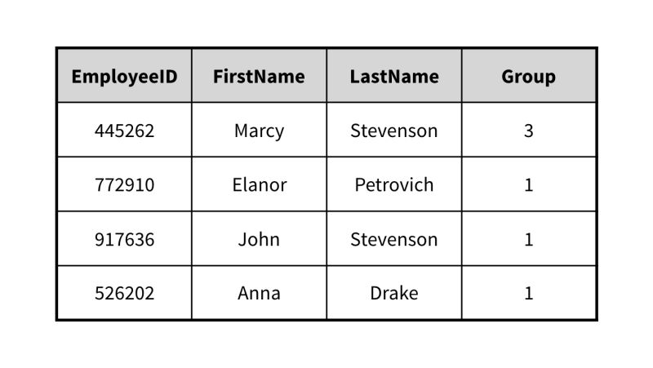

Incorrect

This result set does not seem to be filtered by any field.

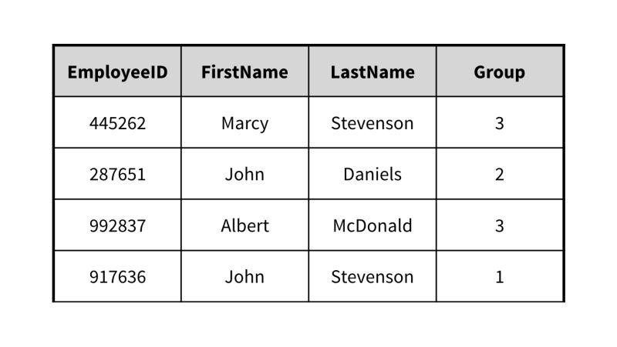

Incorrect

This result set does not seem to be filtered by any field.



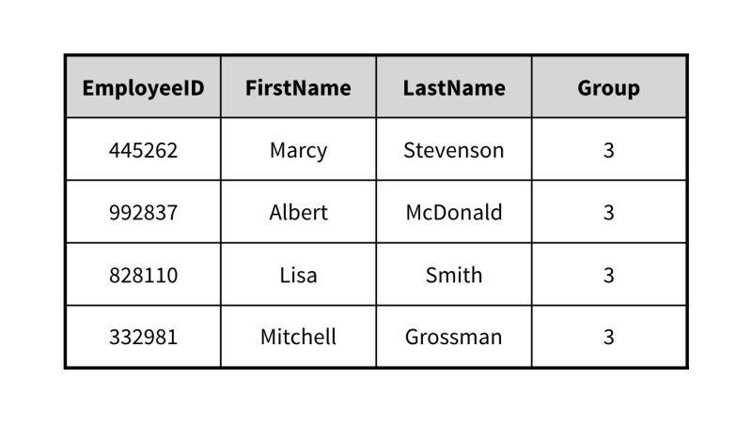

Correct

This result set seems to be the result of limiting the search to employees in group 3.

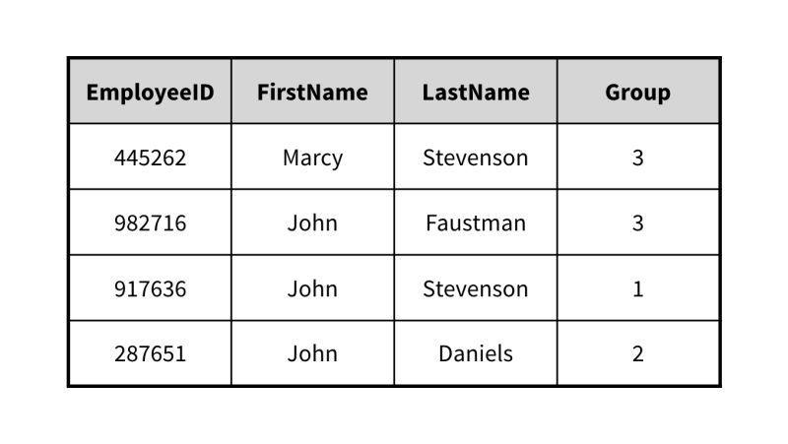

Incorrect

This result set does not seem to be filtered by any field.

Question 16 of 24

You can narrow down the results that a query returns by only asking for results where a _____ matches a given value.

type

Incorrect

This isn't a useful way to filter results. Every field in a column has the same type.

row

Incorrect

Because the order of rows doesn't matter in a relational database, you don't query based on row. But you can simulate this behavior by searching for the primary key, which will always return just one row.

field

Correct

In order to reduce the number of records you get back from a query, you can filter the results based on the contents of a field. For example, you might ask the database to show you records for customers who have their 'State' field set to 'California'.

database

Incorrect

You can only ask for results from tables, not from whole databases.

Question 17 of 24

Which of these tasks can you accomplish using SQL as a DML?

inserting a record into a table

Correct

Inserting a record is a data manipulation task.

deleting the database

Incorrect

Deleting the database is a data definition task.

allowing a new user access to read data from a table

Incorrect

Granting access to a table is a data control task.

removing a column from a table

Incorrect

Removing a column from a table is a data definition task.

Question 18 of 24

When first defining a table, what should you specify? (find 3 correct items)

A. the table's name

B. the table padding

C. the fields and type of data they contain

D. the data per cell

E. the primary key and any referential constraints

B, C, E

Incorrect

Table padding is not a part of initially defining a table. That's more in the UX realm.

A, B, D

Incorrect

Table padding is not a part of initially defining a table. That's more in the UX realm.

C, D, E

Incorrect

You don't specify the data per cell when initially defining a table. That comes later.

A, C, E

Correct

Without this information, you can't fully define a table.

Question 19 of 24

Which sorting option shows dates from latest to earliest?

ORDER BY `Date`

Incorrect

With no order specified, ascending order is used by default and the earliest dates are shown first.

ORDER BY `Date` DESC

Correct

The DESC option will sort in descending order and show the latest dates first.

ORDER BY `Date` LAST

Incorrect

This sorting option will actually error out because LAST is not a valid sort order.

ORDER BY `Date` ASC

Incorrect

The ASC option will sort in ascending order and show the earliest dates first.

Question 20 of 24

When you use SQL statements to create or modify the structure of a database, what is SQL being used as?

a Data Manipulation Language (DML)

Incorrect

As a Data Manipulation Language, SQL can be used to create, read, update, and delete information stored in the database.

a Database Management Solution (DBMS)

Incorrect

SQL is not a DBMS, but it is used by most DBMSs.

a Data Definition Language (DDL)

Correct

As a Data Definition Language, SQL can be used to create and modify the structure of database tables.

a Data Control Language (DCL)

Incorrect

As a Data Control Language, SQL can be used to allow or disallow access to certain tables.

Question 21 of 24

What is the correct SQL syntax to use when joining tables A and B on their "ID" field?

SELECT * FROM A

JOIN ON ID

Incorrect

This statement does not specify which table should be joined with table A.

SELECT * FROM A

JOIN B ON ID

Incorrect

This statement is missing the proper matching condition for the tables to be joined.

SELECT * FROM A

JOIN B

Incorrect

This statement does not specify the field on which the two tables should be joined.

SELECT * FROM A

JOIN B ON A.ID=B.ID

Correct

The join statement specifies the field on which the two tables will be joined.

Question 22 of 24

When telling the database that a certain field must not contain an empty value, you say that it is:

not empty

Incorrect

Close, but there's a specific condition that represents an empty value.

populated

Incorrect

The concept is similar, but you express this in terms of not allowing a null value.

not null

Correct

For some fields, you might want to prohibit entering records with empty values. By telling the database that the field can't be null, the database will handle this restriction for you.

Required

Incorrect

Requiring the field to not be empty has the effect of making it a 'required' field, but there's a different term for the condition.

Question 23 of 24

For a table that holds the purchase amounts in a grocery store over time, which query will likely return the highest value?

SELECT AVG(amount) FROM purchases;

Incorrect

While some purchases may be large, their average is not likely very high.

SELECT MAX(amount) FROM purchases;

Incorrect

While a customer can make an occasional large purchase, this large purchase is still limited in its amount.

SELECT SUM(amount) FROM purchases;

Correct

The purchase amounts will grow over time and add up to a very large sum.

SELECT COUNT(amount) FROM purchases;

Incorrect

Under the likely assumption that normal purchases are over $1, the total number of purchases is not the highest value.

Question 24 of 24

What is the possible issue with this query?

UPDATE mytable SET price=5;

It must delete the records before updating.

Incorrect

An UPDATE command actually only works on records if they already exist, and does not require them to be deleted first and recreated.

It may update undesired records.

Correct

Without a WHERE condition, this query will update all records including possibly undesired ones.

It will update a field to a numeric value.

Incorrect

While this query will set a numeric value in the updated fields, this is not necessarily an issue if the fields are supposed to be numeric.

It may only update one record.

Incorrect

As specified, this query has no filtering and will actually operate on all records in the table.

## 6. Further Database Topics

### 1. Indexes, transactions, and stored procedures

### 2. Access control, compliance, and injection

### 3. Software options

### Chapter Quiz

Question 1 of 8

Which database is often used in a big data context?

FileMaker Pro

Incorrect

FileMaker Pro is actually used for smaller desktop databases.

NoSQL

Incorrect

NoSQL is actually used to store information, not for relations or tables.

SQLite

Incorrect

SQLite is actually used for lighter mobile applications.

Hadoop

Correct

Hadoop and Spark are often used for big data applications.

Question 2 of 8

Microsoft Access is generally considered a(n) _____ database platform.

NoSQL

Incorrect

MS Access is a traditional relational database. There are other solutions for NoSQL.

enterprise

Incorrect

Enterprise database platforms are usually intended for thousands of users. MS Access has a different audience.

mobile-friendly

Incorrect

If you need a database provider on mobile devices, SQLite is a good choice. MS Access is targeted at a different audience.

desktop

This was the correct answer

Question 3 of 8

Relational databases can store all of these except what?

Text

files or binary data

images

Incorrect

Relational databases can store images.

graph data

Correct

Some NoSQL databases are designed to store data arranged as graphs rather than in relations.

Question 4 of 8

A stored procedure is _____.

the same as a transaction

the term for a query or statement that changes data in the database

Incorrect

A stored procedure doesn't need to modify data. Many stored procedures are simply written for reporting purposes.

a predefined query or statement

Correct

Stored procedures are queries that are stored on the server, and they can be called by developers or users in their queries.

a query that the user ran previously

Question 5 of 8

An index _____.

is something you should define for every column in a table

Incorrect

Indexes should be reserved for columns or fields that will be used for searching. Adding an index to every column is usually unnecessary and creates a slowdown.

helps to increase the speed of lookups using a particular column at the cost of speed while modifying records

Correct

As with denormalization, indexes offer a trade off.

helps to increase the speed of lookups using a particular column, with no side effects

sorts the data in a table based on a particular column

Question 6 of 8

What is it called when a malicious user tries to change the way a SQL statement works by entering their own SQL?

malware

injection

Correct

This kind of attack involves someone injecting their own code into an application.

attacking

leaking

Question 7 of 8

If you store certain kinds of information, your database may be subject to certain compliance regulations.

FALSE

Incorrect

If you store personally identifiable information (PII), health information, or some other kinds of information, your database may be subject to various regulations. Be sure to do your research and stay in compliance!

TRUE

This was the correct answer

Question 8 of 8

What is a database transaction?

a group of statements that runs or fails as a whole

a single query that does not involve parameters

Incorrect

Transactions actually consist of multiple queries that often involve parameters.

a saved set of steps that can be executed following a predefined schedule

Incorrect

Many databases support saved sets of steps, but these are not called transactions.

a database query that involves a financial transaction

## 7. Conclusion

### 1. Next steps

### 2. More learning possibilities

Congratulations!  Now that you’ve had a first detailed exploration of databases, you’re ready to dig deeper.

If you’d like to dive deeper into relational databases and SQL, [SQL Essential Training](https://www.linkedin.com/learning/sql-essential-training-20685933/the-data-driven-world-19067626?u=83641554) will bring you more directly into development, and [Solve Real-World Problems with SQL](https://www.linkedin.com/learning/solve-real-world-data-problems-with-sql/advancing-your-skills-with-sql?u=83641554) will show you how to apply its logic to challenging situations. You can also use the [SQL Practice courses](https://www.linkedin.com/learning/search?entityType=COURSE&keywords=SQL%20Practice&u=83641554) to dive deeper.

If relational tables didn’t seem like the right fit for the kinds of projects you want to build, you might want compare [NoSQL possibilities](https://www.linkedin.com/learning/sql-vs-nosql-which-database-type-is-right-for-you/what-kind-of-database-to-choose?u=83641554). You might also want to consider your choices among [relational database software packages](https://www.linkedin.com/learning/choosing-a-database-postgresql-mysql-mongo-and-cloud/choosing-the-right-data-platform?u=83641554).